To determine the exact name of fields used in the tables for these exercises, refer to the tables you created from the Assignment Script Fall 2017.sql, or use the **DESCRIBE *tablename*** command to view the table's **structure.**

1. Display a list of all the customers in the CUSTOMER_X table. (15 points)

Attach SQL statement here= *select* from customer_x;*

Attach screen shots of your script output here

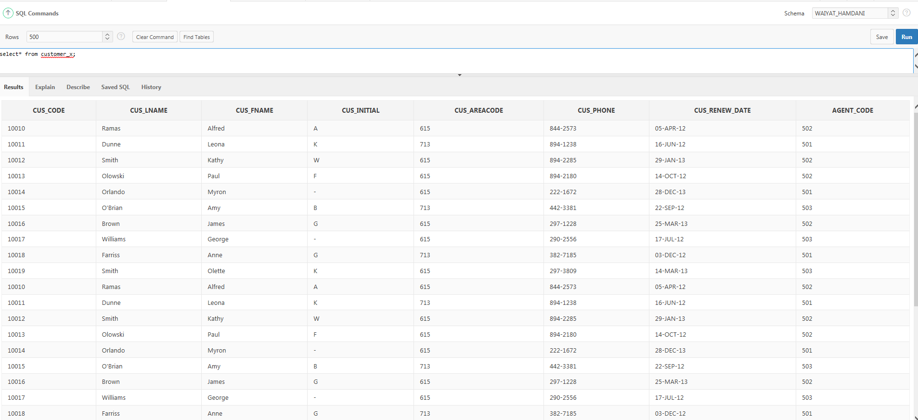

1. List the **course description of all the courses** in the COURSE Table. (15 points)

Attach SQL statement here= *select CRS_DESCRIPTION from course;*

Attach screen shots of your script output here

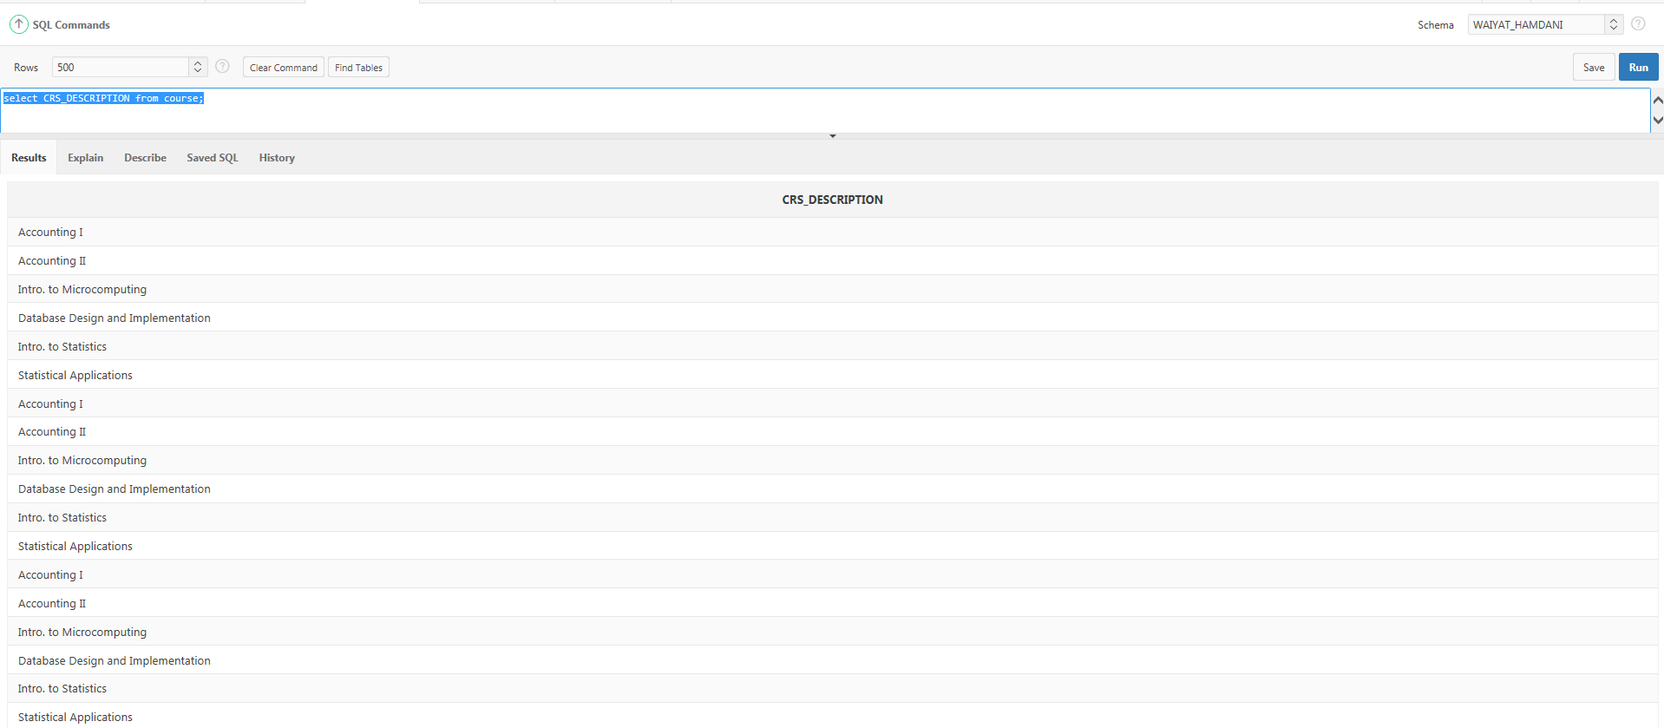

1. List the **course code for all classes in the CLASS table. List each class only once.** (15 points)

Attach SQL statement here= *select distinct CRS_CODE from class;*

Attach screen shots of your script output here

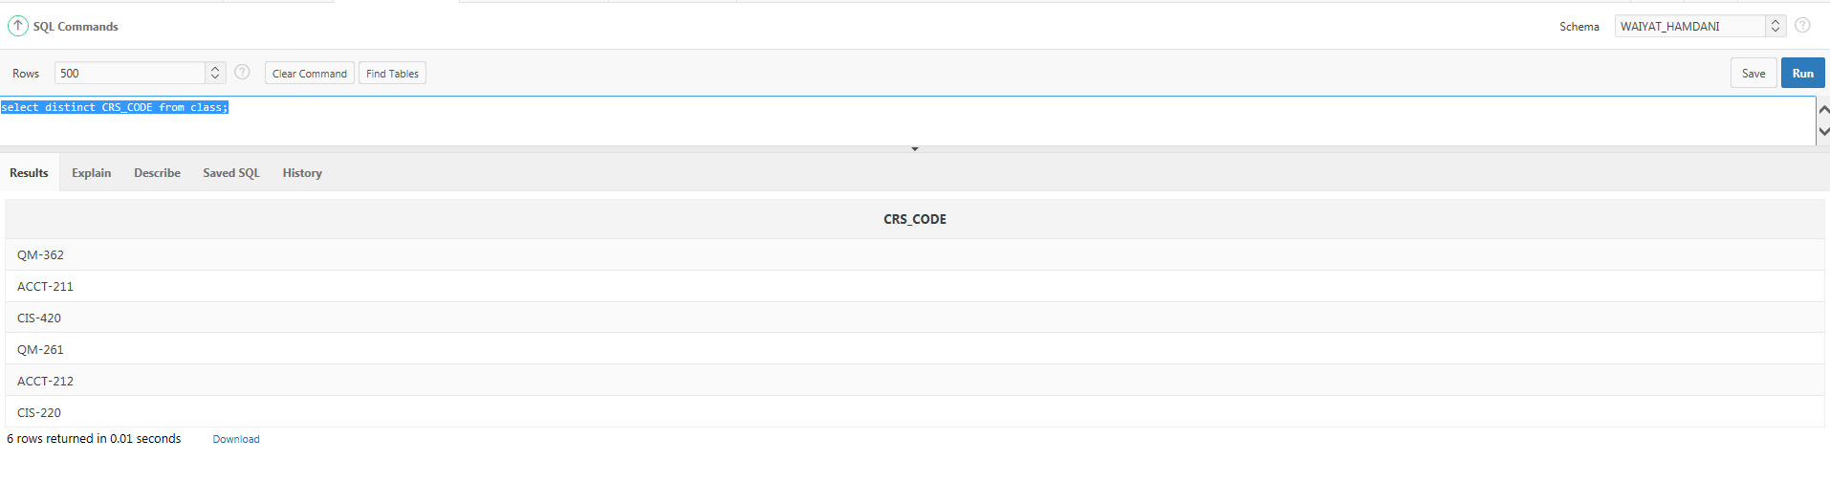

1. Select **the first name, and last of all the students in the STUDENT table. The last names and first names should be separated by a comma and a blank space**. (15 points)

Attach SQL statement here= *select STU_FNAME, STU_LNAME from student;*

Attach screen shots of your script output here

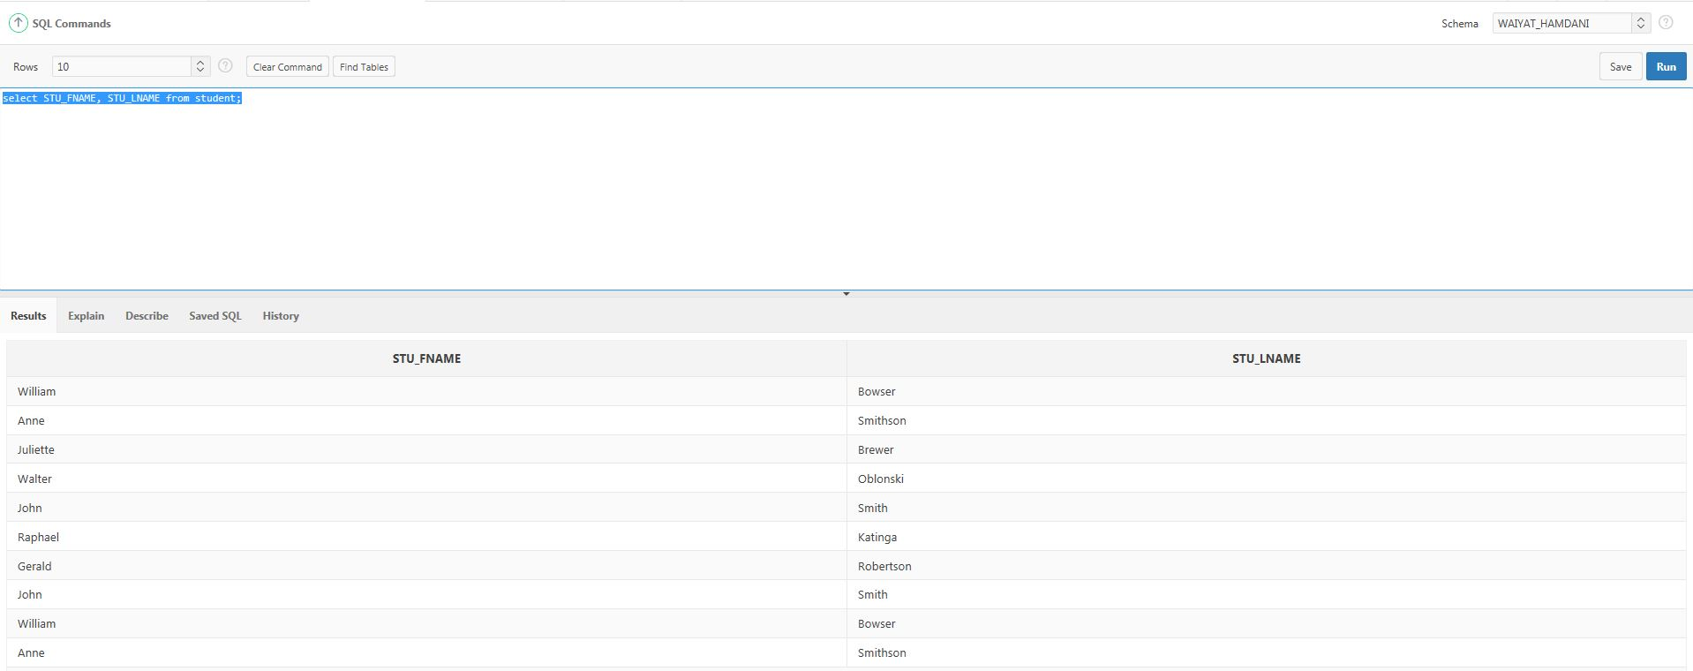

1. List the **distinct categories in the ITEM TABLE**. (15 points)

Attach SQL statement here=*select distinct category from ITEM;*

Attach screen shots of your script output here

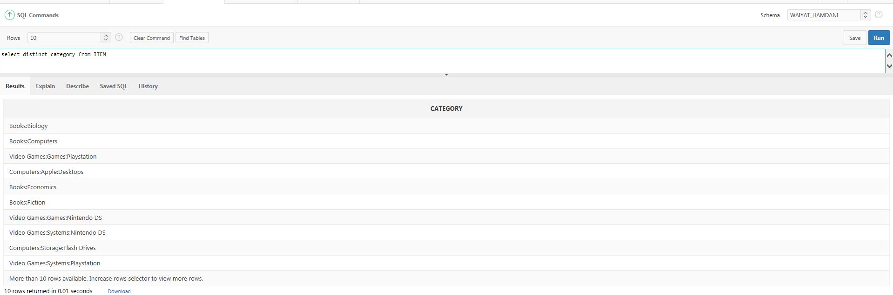

1. List **the all the titles in the ITEM table and what is the highest bid obtainable if there was one bid a day placed on each item.** (25 points)

Attach SQL statement here=*select title, round((CLOSEDATETIME-OPENDATETIME)* BIDINCREMENT + STARTINGBID,2) from item;*

Attach screen shots of your script output here

